**Notes on RANOVA**

1. **Nested factors VS CROSSED factors**

“Because each subject was assigned to only one training group, subject and group are not crossed. Rather, subject is nested within training group.”

<http://www.theanalysisfactor.com/the-difference-between-crossed-and-nested-factors/>

1. **Running a Nested ANOVA in Stata**

http://www.reed.edu/psychology/stata/analyses/parametric/ANOVA/nested.html

1. **Repeated measures anova controlling for covariates**
   1. Anova command

anova datapert1 **c.std_fin** group / id#group condition group#condition, repeated(condition)

* 1. Mixed command

mixed datapert1 **c.std_fin** group##condition || id: , reml dfmethod(satterthwaite)

**Comparisons of various methods to assess differences between groups**

**Conclusion: 2 way RANOVA it the most appropriate method**

1. **2-way RANOVA – “mixed” command (fixed factors || random factors:)**



1. **2 way RANOVA [anova command (main factor, ..)]**



1. **2 way - ANOVA – No repeated measures**



1. **1 way ANOVA for the difference A2-A1 (equivalent to a paired t-test)**



1. **Paired t-test (equivalent to one-way ANOVA)**



RANOVA MIXED (mixed **parameterOfInterest** **c.covariate1** **c.covariate2** group##condition || id:)

|  |  |  |  |  |  |
| --- | --- | --- | --- | --- | --- |
|  | Covariates | Group | Condition | Group by condition |  |
| SLA_1 |  | 0.5 | 0.002 | 0.664 |  |
|  | STD_PERC_VAR | 0.5 | 0.002 | 0.664 |  |
| SLA_1-5 |  | 0.411 | 0.001 | 0.84 |  |
|  | STD_PERC_VAR | 0.4 | 0.001 | 0.84 |  |
| SLA 6-30 |  | 0.6 | 0.001 | 0.9 |  |
|  | STD_PERC_VAR | 0.6 | 0.001 | 0.9 |  |
| SLA SS |  | 0.09 | 0.001 | 0.09 |  |
|  | STD_PERC_VAR | 0.08 | 0.001 | 0.09 |  |
| AVG STR 2 MIDP |  | 0.978 | 0.165 | 0.11 |  |
|  | SLA_1, SLA SS | 0.737 | 0.289 | 0.041 |  |

**COMPARISONS CONSIDERED EXPERIMENTS**

**INTERFERENCE**

* FIRST BASELINE: MEAN: 1.05 m/s, 150 strides
* RATIO: 2/1, delta 0.7 m/s

**YASHAR**

* FIRST BASELINE: SLOW (0.5m/s), 150 strides
* THIRD BASELINE: MEAN (1 M/S), 150 strides
* RATIO 3/1, delta 1 m/s

**NICO**

* FIRST BASELINE: MEAN: 0.75 m/s, 150 strides
* SECOND BASELINE: MEAN 0.75 M/S, 150 strides
* RATIO 2/1, delta 0.5 m/s

**NICO + YASHAR FIRST BASELINE**

1. Std decreases during the first baseline pval=0.03
2. Height and STD_FIN_1 are not correlated with SLA_A1_1 and the linear model including both regressors is not significant

Linear regression model:

y ~ 1 + x1 + x2

Estimated Coefficients:

Estimate SE tStat pValue

_________ _________ ________ ________

(Intercept) -1.8512 1.0106 -1.8317 0.091921

x1 0.0089046 0.0059898 1.4866 0.16291

x2 -2.4013 2.5654 -0.93603 0.36771

Number of observations: 15, Error degrees of freedom: 12

Root Mean Squared Error: 0.159

R-squared: 0.174, Adjusted R-Squared 0.0365

F-statistic vs. constant model: 1.27, p-value = 0.317

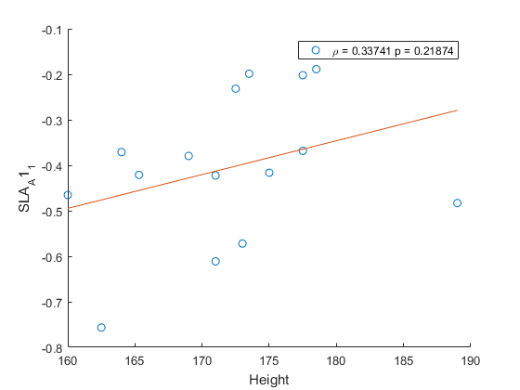

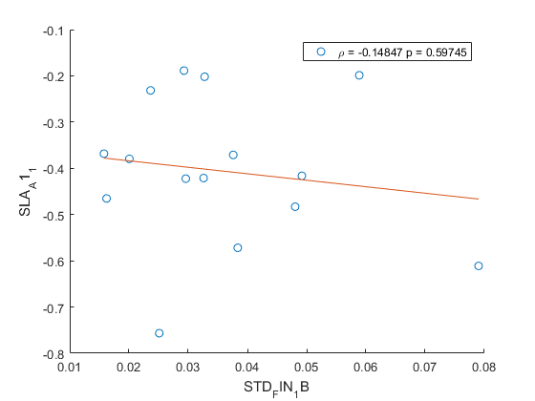

**NICO + YASHAR 2ND BASELINE**

1. STD does not decrease during this baseline p=0.06
2. No correlation; linear model is not a good model

Linear regression model:

y ~ 1 + x1 + x2

Estimated Coefficients:

Estimate SE tStat pValue

________ _________ _______ ________

(Intercept) -1.5338 0.90589 -1.6931 0.1162

x1 0.007462 0.0052438 1.423 0.18021

x2 -7.0662 3.7014 -1.9091 0.080448

Number of observations: 15, Error degrees of freedom: 12

Root Mean Squared Error: 0.144

R-squared: 0.32, Adjusted R-Squared 0.207

F-statistic vs. constant model: 2.83, p-value = 0.0986

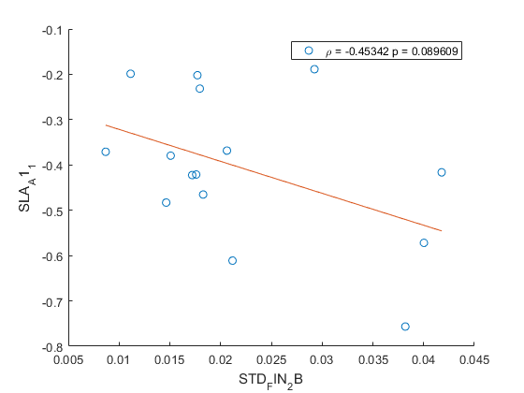

**IDEA 1: only use NICO’s data**

1. **Std during baseline 1 does not change p=0.06**
2. **Std during baseline 2 neither p=0.14**

**USING BASELINE 1**

Linear regression model:

y ~ 1 + x1 + x2

Estimated Coefficients:

Estimate SE tStat pValue

________ ________ ________ _______

(Intercept) -3.7866 1.8396 -2.0584 0.1317

x1 0.020286 0.011127 1.8232 0.16578

x2 -3.158 6.8401 -0.46169 0.67572

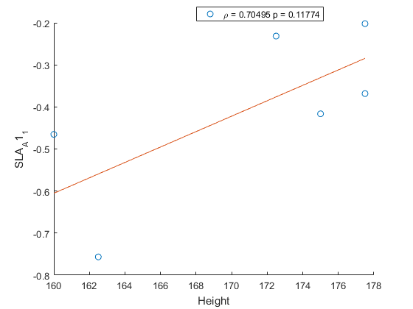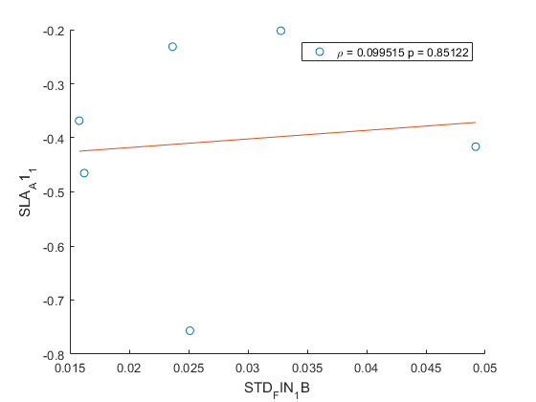

**USING BASELINE 2**

Linear regression model:

y ~ 1 + x1 + x2

Estimated Coefficients:

Estimate SE tStat pValue

________ _________ _______ ________

(Intercept) -2.9375 1.1294 -2.6009 0.080313

x1 0.016361 0.0064822 2.524  **0.085878**

x2 -10.256 4.4804 -2.289 **0.10606**

